4 модуль 2 лабораторная

Нуриева Ольга

1. Для заданной на схеме schema-lab2 сети, состоящей из управляемых коммутаторов и персональных компьютеров настроить протокол STP, назначив явно один из коммутаторов корневым настройкой приоритета

**Для свичей 2-5**

enable

config t

spanning-tree mode ? //узнать какие протоколы поддерживает stp, выбираем режим pvst

spanning-tree mode pvst

spanning-tree vlan 1 включаем stp на коммутаторе

exit

show spanning-tree // проверяем приоритет когда вышли из конфига

**Для свича 1**

enable

config t

spanning-tree mode pvst

spanning-tree vlan 1 priority 4096 \\ включаем stp на коммутаторе

exit

1. Проверить доступность каждого с каждым всех персональных компьютеров (VPCS), результаты запротоколировать

|  |  |
| --- | --- |
| 1 | 192.168.1.1 |
| 2 | 192.168.1.2 |
| 3 | 192.168.1.3 |
| 4 | 192.168.1.4 |
| 5 | 192.168.1.5 |
| 6 | 192.168.1.6 |

1пк

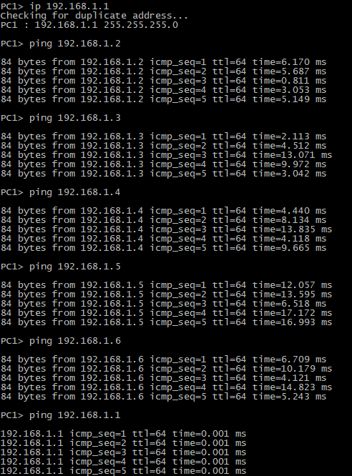

2пк

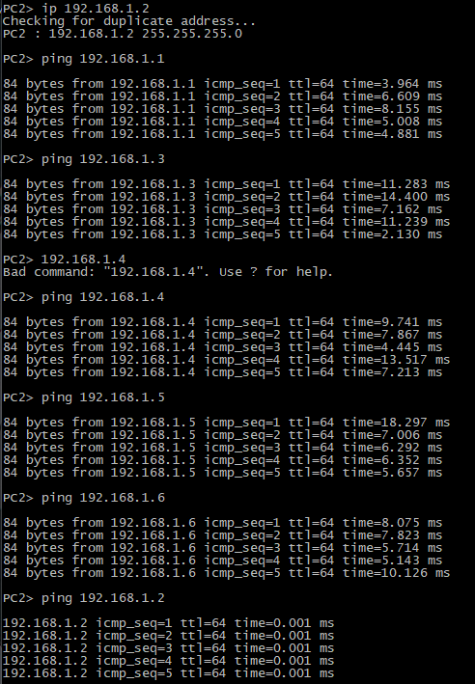

3пк

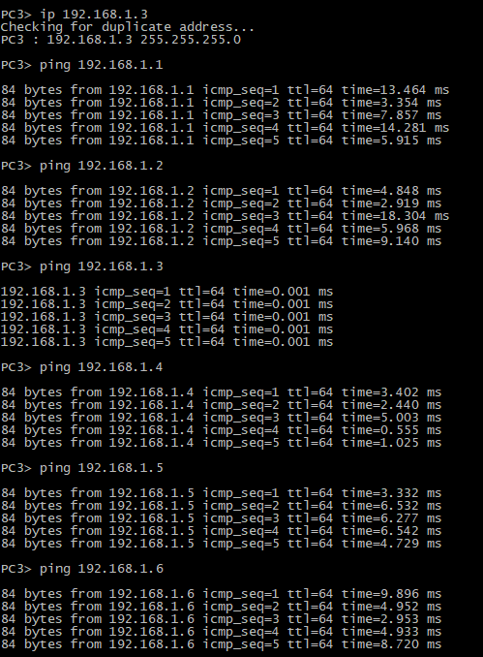

4пк

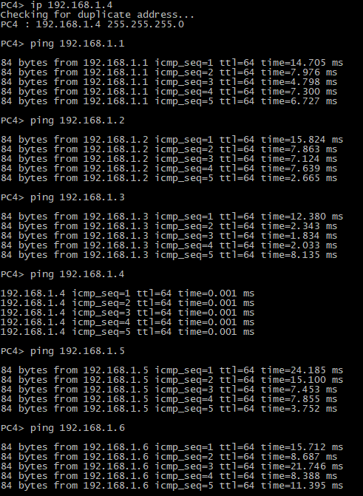

5пк

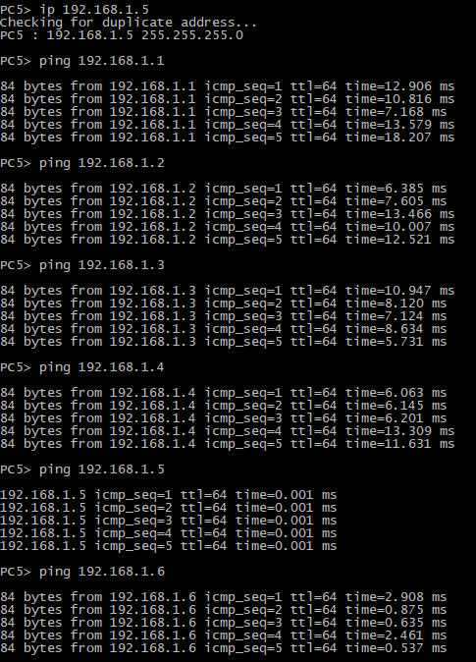

6пк

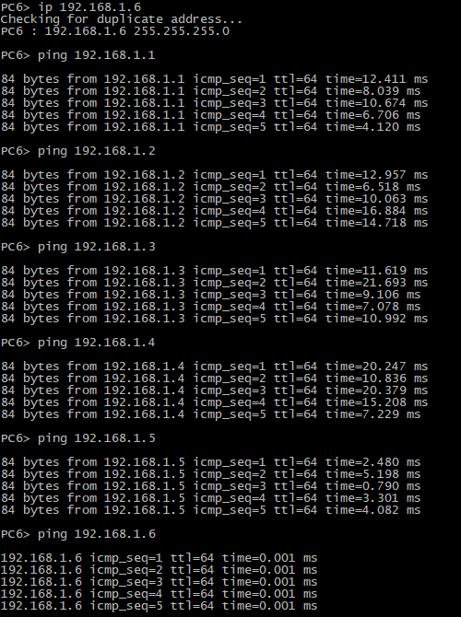

1. На изображении схемы отметить BID каждого коммутатора и режимы работы портов (RP/DP/blocked) и стоимости маршрутов, результат сохранить в файл

show spanning-tree // проверяем приоритет когда вышли из конфига

1свич 1. RP/DP/blocked 2- BID,стоимости маршрутов

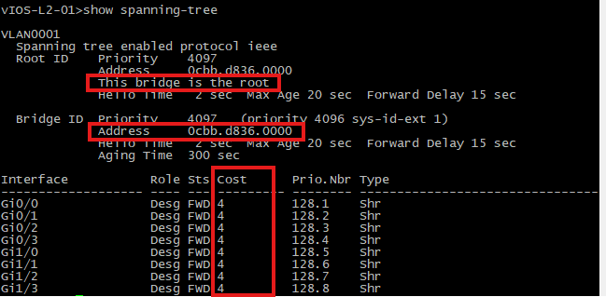

2 свич

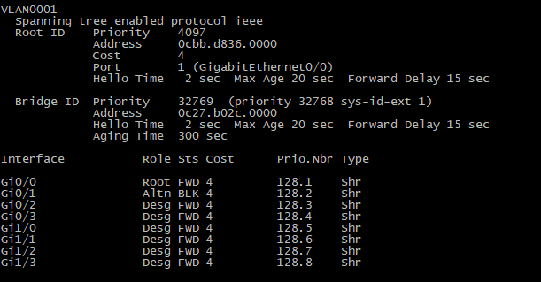

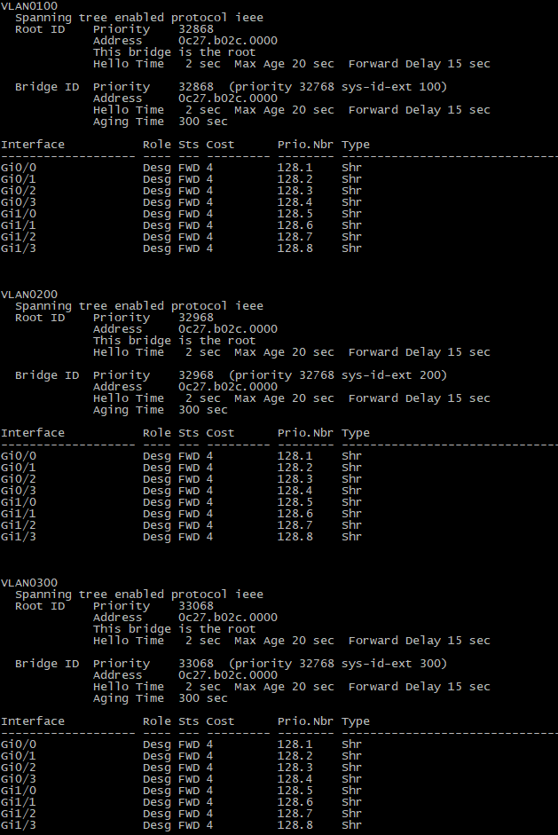

3 свич

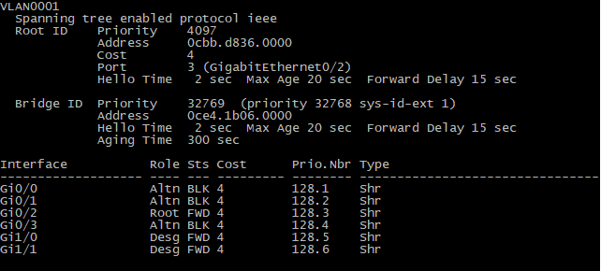

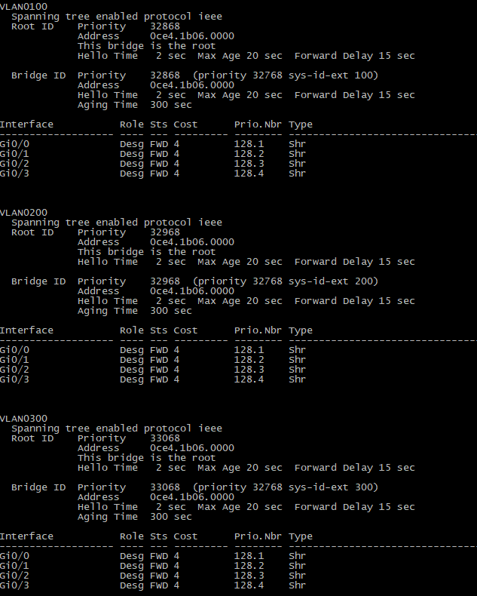

4 свич

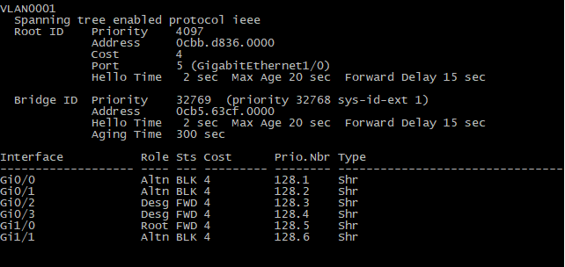

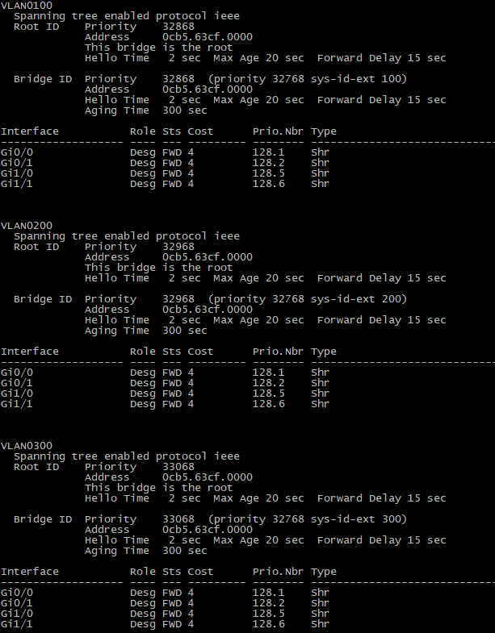

1. свич

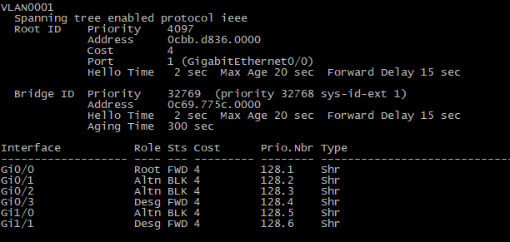

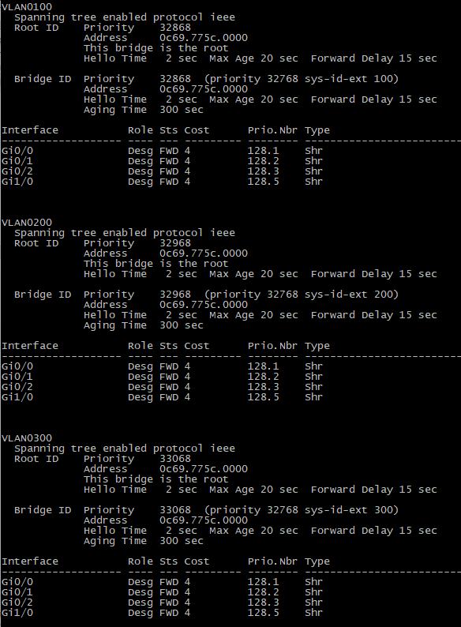

1. При помощи wireshark отследить передачу пакетов hello от корневого коммутатора на всех линках (nb!), результаты включить в отчет

1 линк

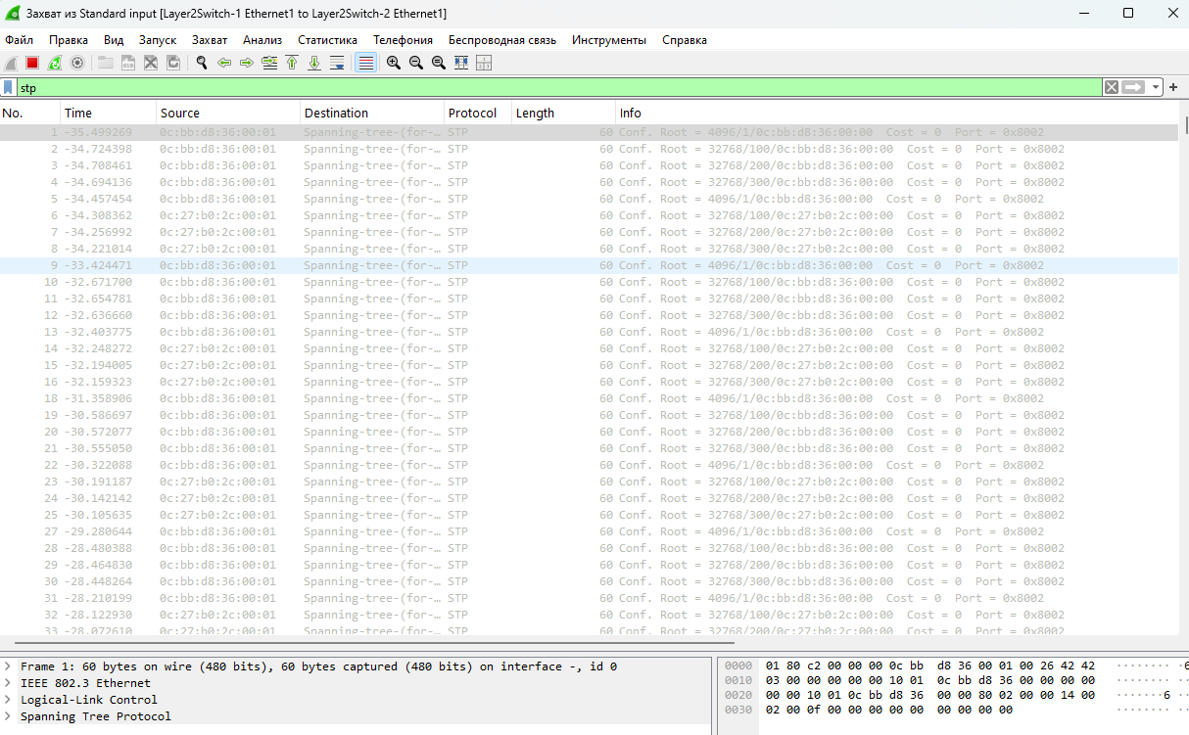

2 линк

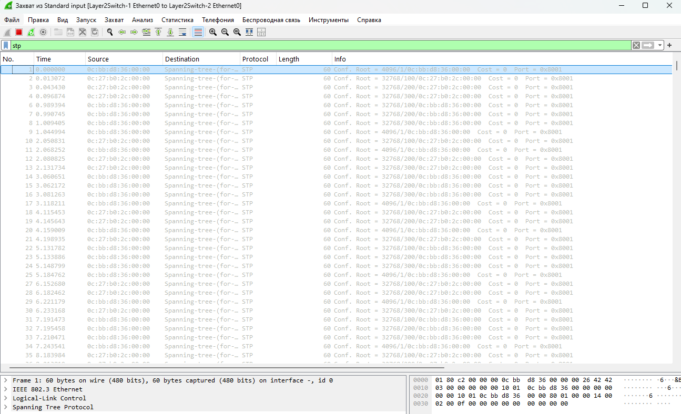

3 линк

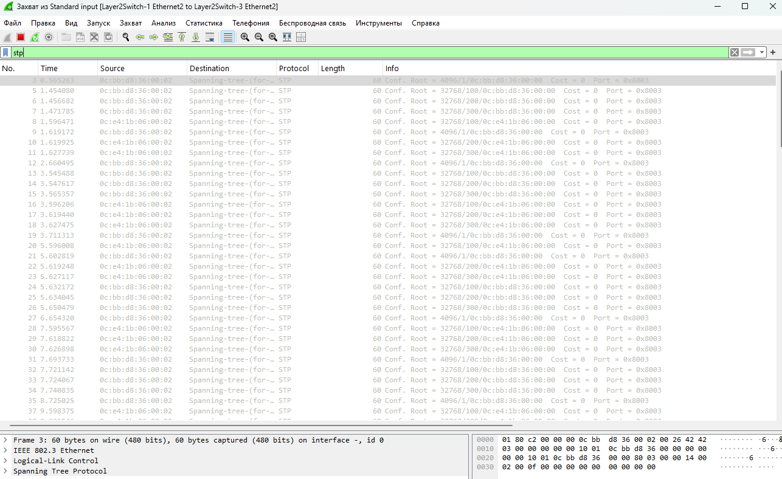

4 линк

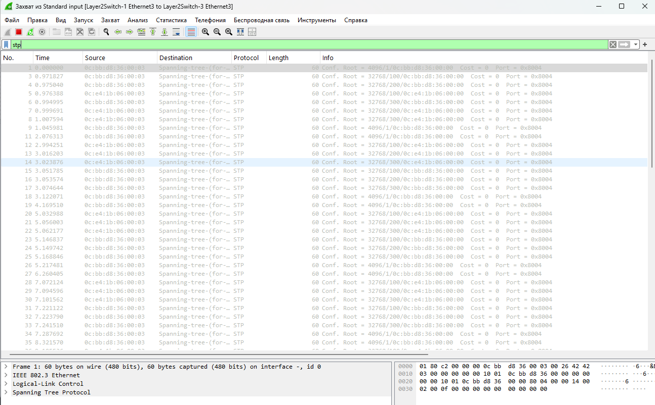

5 линк

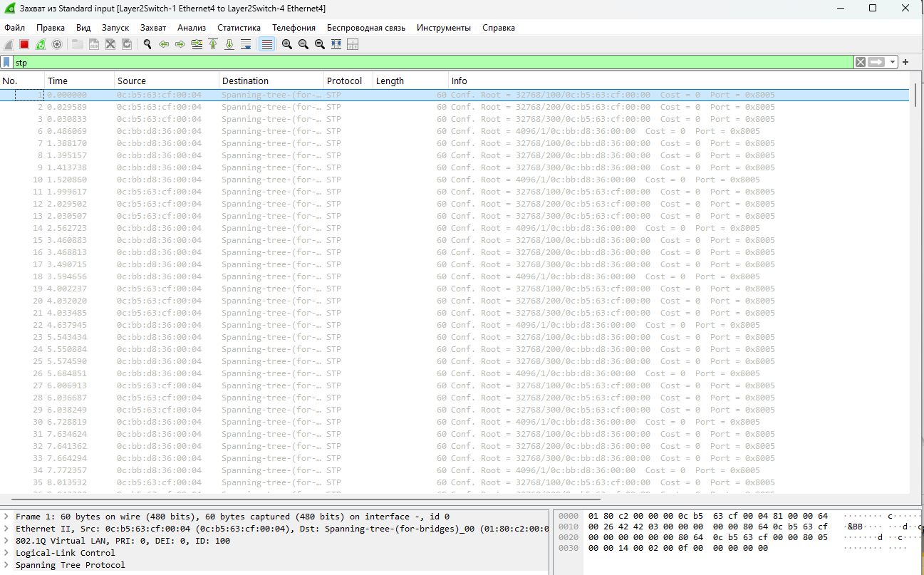

6 линк

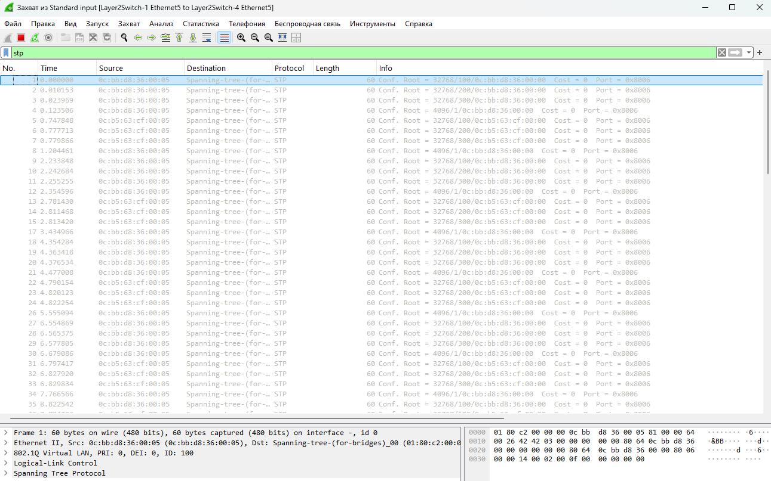

7 линк

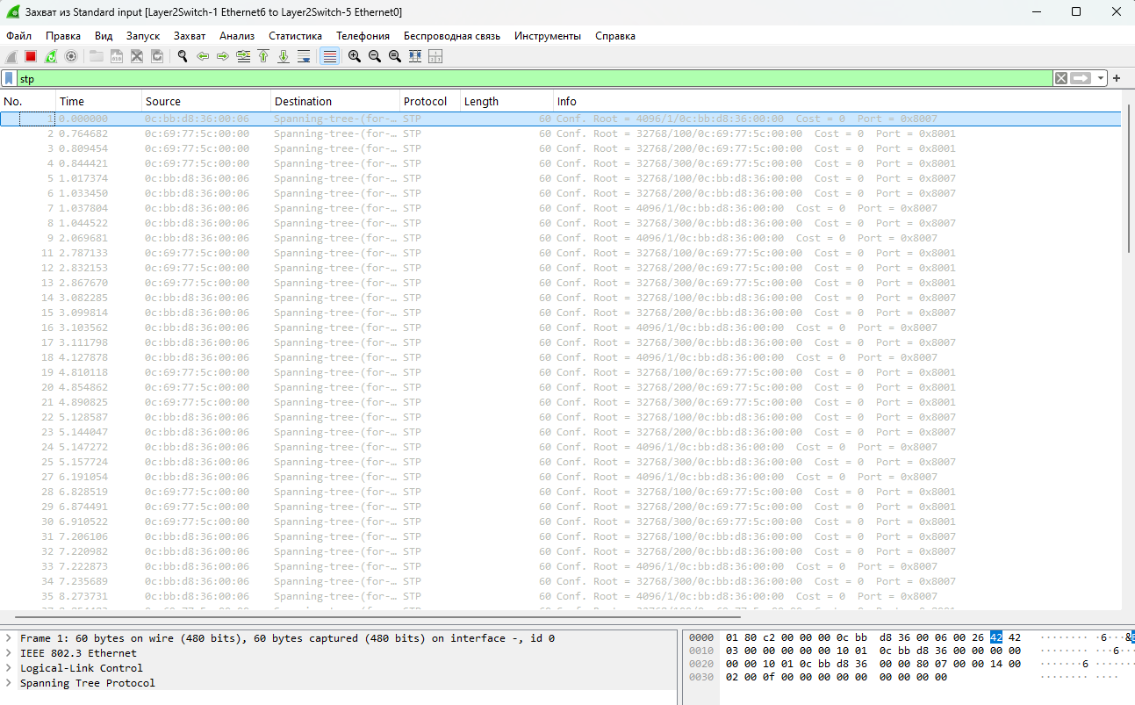

8 линк

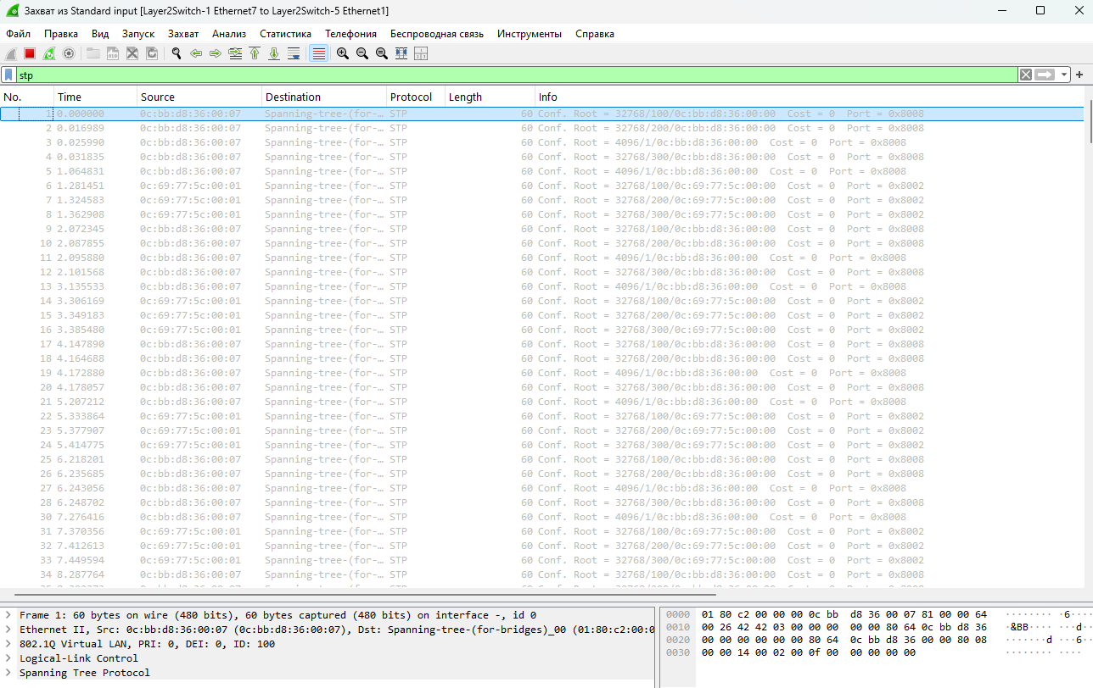

1. Изменить стоимость маршрута для порта RP произвольного назначенного (designated) коммутатора, повторить действия из п.3, результат сохранить в отдельный файл

show interface // посмотреть список доступных интерфейов

enable

config t

interface GigabitEthernet0/2

spanning-tree cost 10 //устанавливаем цену

show spanning-tree //cмотрим резултат

Результат

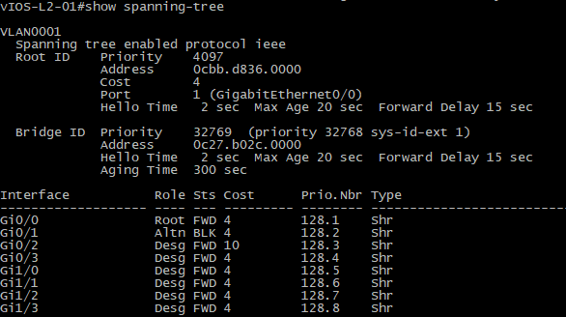

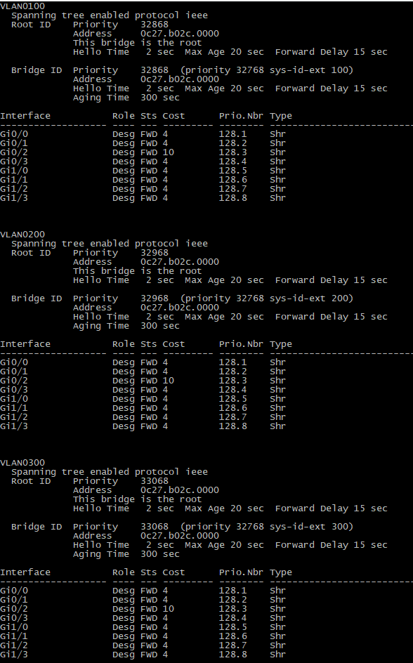

1. Сохранить файлы конфигураций устройств в виде набора файлов с именами, соответствующими именам устройств

|  |
| --- |
| **Switch1.conf** |
| =~=~=~=~=~=~=~=~=~=~=~= PuTTY log 2024.12.19 14:48:56 =~=~=~=~=~=~=~=~=~=~=~=  sh run  Building configuration...  Current configuration : 5211 bytes  !  ! Last configuration change at 06:29:52 UTC Thu Dec 19 2024  !  version 15.0  service timestamps debug datetime msec  service timestamps log datetime msec  no service password-encryption  service compress-config  !  hostname vIOS-L2-01  !  boot-start-marker  boot-end-marker  !  !  !  no aaa new-model  !  !  !  !  !  vtp domain CISCO-vIOS  vtp mode transparent  !  !  !  ip cef  no ipv6 cef  !  !  !  spanning-tree mode pvst  spanning-tree extend system-id  spanning-tree vlan 1 priority 4096  !  vlan internal allocation policy ascending  !  vlan 100  name VLAN100  !  vlan 200,300  !  !  !  !  !  !  !  !  !  !  !  !  !  interface GigabitEthernet0/0  media-type rj45  negotiation auto  !  interface GigabitEthernet0/1  media-type rj45  negotiation auto  !  interface GigabitEthernet0/2  media-type rj45  negotiation auto  !  interface GigabitEthernet0/3  media-type rj45  negotiation auto  !  interface GigabitEthernet1/0  media-type rj45  negotiation auto  !  interface GigabitEthernet1/1  media-type rj45  negotiation auto  !  interface GigabitEthernet1/2  media-type rj45  negotiation auto  !  interface GigabitEthernet1/3  media-type rj45  negotiation auto  !  ip forward-protocol nd  !  no ip http server  no ip http secure-server  !  !  !  !  !  !  control-plane  !  banner exec ^C  **************************************************************************  * IOSv - Cisco Systems Confidential *  * *  * This software is provided as is without warranty for internal *  * development and testing purposes only under the terms of the Cisco *  * Early Field Trial agreement. Under no circumstances may this software *  * be used for production purposes or deployed in a production *  * environment. *  * *  * By using the software, you agree to abide by the terms and conditions *  * of the Cisco Early Field Trial Agreement as well as the terms and *  * conditions of the Cisco End User License Agreement at *  * http://www.cisco.com/go/eula *  * *  * Unauthorized use or distribution of this software is expressly *  * Prohibited. *  **************************************************************************^C  banner incoming ^C  **************************************************************************  * IOSv - Cisco Systems Confidential *  * *  * This software is provided as is without warranty for internal *  * development and testing purposes only under the terms of the Cisco *  * Early Field Trial agreement. Under no circumstances may this software *  * be used for production purposes or deployed in a production *  * environment. *  * *  * By using the software, you agree to abide by the terms and conditions *  * of the Cisco Early Field Trial Agreement as well as the terms and *  * conditions of the Cisco End User License Agreement at *  * http://www.cisco.com/go/eula *  * *  * Unauthorized use or distribution of this software is expressly *  * Prohibited. *  **************************************************************************^C  banner login ^C  **************************************************************************  * IOSv - Cisco Systems Confidential *  * *  * This software is provided as is without warranty for internal *  * development and testing purposes only under the terms of the Cisco *  * Early Field Trial agreement. Under no circumstances may this software *  * be used for production purposes or deployed in a production *  * environment. *  * *  * By using the software, you agree to abide by the terms and conditions *  * of the Cisco Early Field Trial Agreement as well as the terms and *  * conditions of the Cisco End User License Agreement at *  * http://www.cisco.com/go/eula *  * *  * Unauthorized use or distribution of this software is expressly *  * Prohibited. *  **************************************************************************^C  !  line con 0  logging synchronous  line aux 0  line vty 0 4  logging synchronous  login  line vty 5 15  logging synchronous  login  !  !  end  vIOS-L2-01# |
| **Switch2.conf** |
| =~=~=~=~=~=~=~=~=~=~=~= PuTTY log 2024.12.19 14:54:12 =~=~=~=~=~=~=~=~=~=~=~=  sh run  Building configuration...  Current configuration : 5197 bytes  !  ! Last configuration change at 07:38:19 UTC Thu Dec 19 2024  !  version 15.0  service timestamps debug datetime msec  service timestamps log datetime msec  no service password-encryption  service compress-config  !  hostname vIOS-L2-01  !  boot-start-marker  boot-end-marker  !  !  !  no aaa new-model  !  !  !  !  !  vtp domain CISCO-vIOS  vtp mode transparent  !  !  !  ip cef  no ipv6 cef  !  !  spanning-tree mode pvst  spanning-tree extend system-id  !  vlan internal allocation policy ascending  !  vlan 100  name VLAN100  !  vlan 200,300  !  !  !  !  !  !  !  !  !  !  !  !  !  interface GigabitEthernet0/0  media-type rj45  negotiation auto  !  interface GigabitEthernet0/1  media-type rj45  negotiation auto  !  interface GigabitEthernet0/2  media-type rj45  negotiation auto  spanning-tree cost 10  !  interface GigabitEthernet0/3  media-type rj45  negotiation auto  !  interface GigabitEthernet1/0  media-type rj45  negotiation auto  !  interface GigabitEthernet1/1  media-type rj45  negotiation auto  !  interface GigabitEthernet1/2  media-type rj45  negotiation auto  !  interface GigabitEthernet1/3  media-type rj45  negotiation auto  !  ip forward-protocol nd  !  no ip http server  no ip http secure-server  !  !  !  !  !  !  control-plane  !  banner exec ^C  **************************************************************************  * IOSv - Cisco Systems Confidential *  * *  * This software is provided as is without warranty for internal *  * development and testing purposes only under the terms of the Cisco *  * Early Field Trial agreement. Under no circumstances may this software *  * be used for production purposes or deployed in a production *  * environment. *  * *  * By using the software, you agree to abide by the terms and conditions *  * of the Cisco Early Field Trial Agreement as well as the terms and *  * conditions of the Cisco End User License Agreement at *  * http://www.cisco.com/go/eula *  * *  * Unauthorized use or distribution of this software is expressly *  * Prohibited. *  **************************************************************************^C  banner incoming ^C  **************************************************************************  * IOSv - Cisco Systems Confidential *  * *  * This software is provided as is without warranty for internal *  * development and testing purposes only under the terms of the Cisco *  * Early Field Trial agreement. Under no circumstances may this software *  * be used for production purposes or deployed in a production *  * environment. *  * *  * By using the software, you agree to abide by the terms and conditions *  * of the Cisco Early Field Trial Agreement as well as the terms and *  * conditions of the Cisco End User License Agreement at *  * http://www.cisco.com/go/eula *  * *  * Unauthorized use or distribution of this software is expressly *  * Prohibited. *  **************************************************************************^C  banner login ^C  **************************************************************************  * IOSv - Cisco Systems Confidential *  * *  * This software is provided as is without warranty for internal *  * development and testing purposes only under the terms of the Cisco *  * Early Field Trial agreement. Under no circumstances may this software *  * be used for production purposes or deployed in a production *  * environment. *  * *  * By using the software, you agree to abide by the terms and conditions *  * of the Cisco Early Field Trial Agreement as well as the terms and *  * conditions of the Cisco End User License Agreement at *  * http://www.cisco.com/go/eula *  * *  * Unauthorized use or distribution of this software is expressly *  * Prohibited. *  **************************************************************************^C  !  line con 0  logging synchronous  line aux 0  line vty 0 4  logging synchronous  login  line vty 5 15  logging synchronous  login  !  !  end  vIOS-L2-01# |
| **Switch3.conf** |
| =~=~=~=~=~=~=~=~=~=~=~= PuTTY log 2024.12.19 14:55:49 =~=~=~=~=~=~=~=~=~=~=~=  sh run  Building configuration...  Current configuration : 5042 bytes  !  ! Last configuration change at 06:21:59 UTC Thu Dec 19 2024  !  version 15.0  service timestamps debug datetime msec  service timestamps log datetime msec  no service password-encryption  service compress-config  !  hostname vIOS-L2-01  !  boot-start-marker  boot-end-marker  !  !  !  no aaa new-model  !  !  !  !  !  vtp domain CISCO-vIOS  vtp mode transparent  !  !  !  ip cef  no ipv6 cef  !  !  spanning-tree mode pvst  spanning-tree extend system-id  !  vlan internal allocation policy ascending  !  vlan 100  name VLAN100  !  vlan 200,300  !  !  !  !  !  !  !  !  !  !  !  !  !  interface GigabitEthernet0/0  media-type rj45  negotiation auto  !  interface GigabitEthernet0/1  media-type rj45  negotiation auto  !  interface GigabitEthernet0/2  media-type rj45  negotiation auto  !  interface GigabitEthernet0/3  media-type rj45  negotiation auto  !  interface GigabitEthernet1/0  media-type rj45  negotiation auto  !  interface GigabitEthernet1/1  media-type rj45  negotiation auto  !  ip forward-protocol nd  !  no ip http server  no ip http secure-server  !  !  !  !  !  !  control-plane  !  banner exec ^C  **************************************************************************  * IOSv - Cisco Systems Confidential *  * *  * This software is provided as is without warranty for internal *  * development and testing purposes only under the terms of the Cisco *  * Early Field Trial agreement. Under no circumstances may this software *  * be used for production purposes or deployed in a production *  * environment. *  * *  * By using the software, you agree to abide by the terms and conditions *  * of the Cisco Early Field Trial Agreement as well as the terms and *  * conditions of the Cisco End User License Agreement at *  * http://www.cisco.com/go/eula *  * *  * Unauthorized use or distribution of this software is expressly *  * Prohibited. *  **************************************************************************^C  banner incoming ^C  **************************************************************************  * IOSv - Cisco Systems Confidential *  * *  * This software is provided as is without warranty for internal *  * development and testing purposes only under the terms of the Cisco *  * Early Field Trial agreement. Under no circumstances may this software *  * be used for production purposes or deployed in a production *  * environment. *  * *  * By using the software, you agree to abide by the terms and conditions *  * of the Cisco Early Field Trial Agreement as well as the terms and *  * conditions of the Cisco End User License Agreement at *  * http://www.cisco.com/go/eula *  * *  * Unauthorized use or distribution of this software is expressly *  * Prohibited. *  **************************************************************************^C  banner login ^C  **************************************************************************  * IOSv - Cisco Systems Confidential *  * *  * This software is provided as is without warranty for internal *  * development and testing purposes only under the terms of the Cisco *  * Early Field Trial agreement. Under no circumstances may this software *  * be used for production purposes or deployed in a production *  * environment. *  * *  * By using the software, you agree to abide by the terms and conditions *  * of the Cisco Early Field Trial Agreement as well as the terms and *  * conditions of the Cisco End User License Agreement at *  * http://www.cisco.com/go/eula *  * *  * Unauthorized use or distribution of this software is expressly *  * Prohibited. *  **************************************************************************^C  !  line con 0  logging synchronous  line aux 0  line vty 0 4  logging synchronous  login  line vty 5 15  logging synchronous  login  !  !  end  vIOS-L2-01# |
| **Switch4.conf** |
| =~=~=~=~=~=~=~=~=~=~=~= PuTTY log 2024.12.19 14:58:24 =~=~=~=~=~=~=~=~=~=~=~=  sh run  Building configuration...  Current configuration : 5042 bytes  !  ! Last configuration change at 06:26:33 UTC Thu Dec 19 2024  !  version 15.0  service timestamps debug datetime msec  service timestamps log datetime msec  no service password-encryption  service compress-config  !  hostname vIOS-L2-01  !  boot-start-marker  boot-end-marker  !  !  !  no aaa new-model  !  !  !  !  !  vtp domain CISCO-vIOS  vtp mode transparent  !  !  !  ip cef  no ipv6 cef  !  !  spanning-tree mode pvst  spanning-tree extend system-id  !  vlan internal allocation policy ascending  !  vlan 100  name VLAN100  !  vlan 200,300  !  !  !  !  !  !  !  !  !  !  !  !  !  interface GigabitEthernet0/0  media-type rj45  negotiation auto  !  interface GigabitEthernet0/1  media-type rj45  negotiation auto  !  interface GigabitEthernet0/2  media-type rj45  negotiation auto  !  interface GigabitEthernet0/3  media-type rj45  negotiation auto  !  interface GigabitEthernet1/0  media-type rj45  negotiation auto  !  interface GigabitEthernet1/1  media-type rj45  negotiation auto  !  ip forward-protocol nd  !  no ip http server  no ip http secure-server  !  !  !  !  !  !  control-plane  !  banner exec ^C  **************************************************************************  * IOSv - Cisco Systems Confidential *  * *  * This software is provided as is without warranty for internal *  * development and testing purposes only under the terms of the Cisco *  * Early Field Trial agreement. Under no circumstances may this software *  * be used for production purposes or deployed in a production *  * environment. *  * *  * By using the software, you agree to abide by the terms and conditions *  * of the Cisco Early Field Trial Agreement as well as the terms and *  * conditions of the Cisco End User License Agreement at *  * http://www.cisco.com/go/eula *  * *  * Unauthorized use or distribution of this software is expressly *  * Prohibited. *  **************************************************************************^C  banner incoming ^C  **************************************************************************  * IOSv - Cisco Systems Confidential *  * *  * This software is provided as is without warranty for internal *  * development and testing purposes only under the terms of the Cisco *  * Early Field Trial agreement. Under no circumstances may this software *  * be used for production purposes or deployed in a production *  * environment. *  * *  * By using the software, you agree to abide by the terms and conditions *  * of the Cisco Early Field Trial Agreement as well as the terms and *  * conditions of the Cisco End User License Agreement at *  * http://www.cisco.com/go/eula *  * *  * Unauthorized use or distribution of this software is expressly *  * Prohibited. *  **************************************************************************^C  banner login ^C  **************************************************************************  * IOSv - Cisco Systems Confidential *  * *  * This software is provided as is without warranty for internal *  * development and testing purposes only under the terms of the Cisco *  * Early Field Trial agreement. Under no circumstances may this software *  * be used for production purposes or deployed in a production *  * environment. *  * *  * By using the software, you agree to abide by the terms and conditions *  * of the Cisco Early Field Trial Agreement as well as the terms and *  * conditions of the Cisco End User License Agreement at *  * http://www.cisco.com/go/eula *  * *  * Unauthorized use or distribution of this software is expressly *  * Prohibited. *  **************************************************************************^C  !  line con 0  logging synchronous  line aux 0  line vty 0 4  logging synchronous  login  line vty 5 15  logging synchronous  login  !  !  end  vIOS-L2-01# |
| **Switch5.conf** |
| =~=~=~=~=~=~=~=~=~=~=~= PuTTY log 2024.12.19 15:00:04 =~=~=~=~=~=~=~=~=~=~=~=  sh run  Building configuration...  Current configuration : 5042 bytes  !  ! Last configuration change at 06:27:49 UTC Thu Dec 19 2024  !  version 15.0  service timestamps debug datetime msec  service timestamps log datetime msec  no service password-encryption  service compress-config  !  hostname vIOS-L2-01  !  boot-start-marker  boot-end-marker  !  !  !  no aaa new-model  !  !  !  !  !  vtp domain CISCO-vIOS  vtp mode transparent  !  !  !  ip cef  no ipv6 cef  !  !  spanning-tree mode pvst  spanning-tree extend system-id  !  vlan internal allocation policy ascending  !  vlan 100  name VLAN100  !  vlan 200,300  !  !  !  !  !  !  !  !  !  !  !  !  !  interface GigabitEthernet0/0  media-type rj45  negotiation auto  !  interface GigabitEthernet0/1  media-type rj45  negotiation auto  !  interface GigabitEthernet0/2  media-type rj45  negotiation auto  !  interface GigabitEthernet0/3  media-type rj45  negotiation auto  !  interface GigabitEthernet1/0  media-type rj45  negotiation auto  !  interface GigabitEthernet1/1  media-type rj45  negotiation auto  !  ip forward-protocol nd  !  no ip http server  no ip http secure-server  !  !  !  !  !  !  control-plane  !  banner exec ^C  **************************************************************************  * IOSv - Cisco Systems Confidential *  * *  * This software is provided as is without warranty for internal *  * development and testing purposes only under the terms of the Cisco *  * Early Field Trial agreement. Under no circumstances may this software *  * be used for production purposes or deployed in a production *  * environment. *  * *  * By using the software, you agree to abide by the terms and conditions *  * of the Cisco Early Field Trial Agreement as well as the terms and *  * conditions of the Cisco End User License Agreement at *  * http://www.cisco.com/go/eula *  * *  * Unauthorized use or distribution of this software is expressly *  * Prohibited. *  **************************************************************************^C  banner incoming ^C  **************************************************************************  * IOSv - Cisco Systems Confidential *  * *  * This software is provided as is without warranty for internal *  * development and testing purposes only under the terms of the Cisco *  * Early Field Trial agreement. Under no circumstances may this software *  * be used for production purposes or deployed in a production *  * environment. *  * *  * By using the software, you agree to abide by the terms and conditions *  * of the Cisco Early Field Trial Agreement as well as the terms and *  * conditions of the Cisco End User License Agreement at *  * http://www.cisco.com/go/eula *  * *  * Unauthorized use or distribution of this software is expressly *  * Prohibited. *  **************************************************************************^C  banner login ^C  **************************************************************************  * IOSv - Cisco Systems Confidential *  * *  * This software is provided as is without warranty for internal *  * development and testing purposes only under the terms of the Cisco *  * Early Field Trial agreement. Under no circumstances may this software *  * be used for production purposes or deployed in a production *  * environment. *  * *  * By using the software, you agree to abide by the terms and conditions *  * of the Cisco Early Field Trial Agreement as well as the terms and *  * conditions of the Cisco End User License Agreement at *  * http://www.cisco.com/go/eula *  * *  * Unauthorized use or distribution of this software is expressly *  * Prohibited. *  **************************************************************************^C  !  line con 0  logging synchronous  line aux 0  line vty 0 4  logging synchronous  login  line vty 5 15  logging synchronous  login  !  !  end  vIOS-L2-01# |